MOHD HAFFIZ BIN LOKMAN
NO 31 JALAN TERATAI 16,
BUKIT BERUNTUNG,
48300 RAWANG,
SELANGOR DARUL EHSAN.

Dear Hiring Manager,

JOB APPLICATION FOR DRIVE TEST ENGINEER

I am writing this letter to seek an opportunity to work under your company. I am very interested to be considered as a candidate for IT/ Telco Industry. 1 year quiet tough experience in the Testing for RF System Technology for GSM and UMTS/LTE used drive test tools. Worked on multiple vendors equipment in Telecom Industry i.e. Huawei, Nokia, Siemens and Zte and familiar operators in Malaysia. Experienced in Pre & Post Launch Verification and Optimization, Parameter Monitoring and ensure all test case achieving the SSV and KPIs.

Highest Education: Diploma in Control Electronic Engineering

HAFFIZ
Yours sincerely,
(MOHD HAFFIZ BIN LOKMAN)

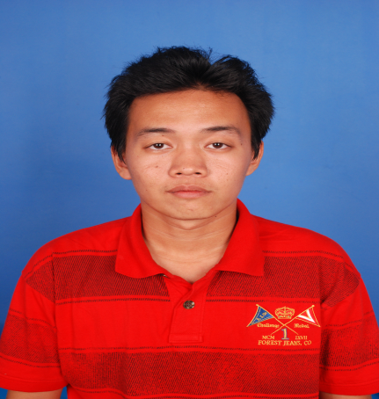

PERSONAL DETAILS

NAME | : | MOHD HAFFIZ BIN LOKMAN
CURRENT ADDRESS | : | NO 31 JALAN TERATAI 16
 |  | BUKIT BERUNTUNG
 |  | 48300 RAWANG
 |  | SELANGOR.
CONTACT No. (MOBILE) | : | +60129732892
EMAIL ADDRESS | : | apiz92boyz@gmail.com
DATE Of BIRTH | : | 3 JANUARY 1992
GENDER | : | MALE
IC No. | : | 920103-14-6099
RACE | : | MALAY
RELIGION | : | MUSLIM
MARITAL STATUS | : | SINGLE

EDUCATIONAL BACKGROUND

PLACE | YEAR | QUALIFICATION / COURSE | GRED
SMK BUKIT BERUNTUNG | 2005 - 2007 | PMR | PASS
SMK BUKIT BERUNTUNG | 2008-2009 | SPM | PASS
POLITEKNIK SULTAN IDRIS SHAH (PSIS) | DECEMBER 2010 - NOVEMBER 2013 | DIPLOMA IN ELECTRONIC ENGINEERING (COMMUNICATION) | PASS

EMPLOYMENT HISTORY

1) COMPANY NAME | : | BURNMARKS SDN.BHD
POSITION TITLE | : | Data entry (key-in-data)  - QC ROBOT WELD
2) COMPANY NAME  POSITION TITLE | : M | ultiwireless Sdn Bhd  DRIVE TEST ENGINEER(DTE)  -Able to handle software related work(currently using Nemo Outdoor)  -Experiend in field almost 2 years.  -Able to perform fast solution for any problem regarding software and hardware during DT test  -2014 – 2015 (U MOBILE ) In JOHOR BHARU.  -Perform drive test measurement on 2G/3G/WiMAX/LTE network.  -Perform Drive Test Analysis and KPI monitoring.  -Perform full SSV, AFS, and SWAP SECTOR.

SKILLS

Proficiency: Advanced - Highly experienced; Intermediate - Familiar with all the basic functionalities; Beginner - Just started using or learning the skill
SKILL |  |  |  |  |  | PROFICIENCY
MS WORDS |  |  |  |  |  | ADVANCED
MS EXCEL |  |  |  |  |  | INTERMEDIATE
MS POWER POINT |  |  |  |  |  | INTERMEDIATE
NEMO OUTDOOR |  |  |  |  |  | ADVANCED
LANGUAGES
Proficiency: 0=Poor - 10=Excellent
LANGUAGE |  |  |  |  | SPOKEN | WRITTEN
BAHASA MALAYSIA |  |  |  |  | 10 | 10
ENGLISH |  |  |  |  | 8 | 8
ADDITIONAL INFO
i) FAST LEARNER
ii) CAN COMPLETE EVERY TASK GIVEN ON TIME OR BEFORE THE DUE
iii) ABLE TO DO WORK RELATED TO MATHEMATICS
iv) ABLE TO WORK ON LONG HOURS PERIOD.

JOB PREFERENCES
EXPECTED SALARY |  |  | : | RM 2500.00 (NEGOTIABLE)
WILLING TO TRAVEL |  |  | : | YES
POSSES OWN TRANSPORT |  |  | : | YES
REFERENCES
NAME | : | AMIRUL ZAHARIN BIN YUSOFF
COMPANY | : | POLITEKNIK SULTAN IDRIS SHAH
POSITION | : | LECTURER
PHONE No. | : | 019 7629037

NAME | : | ZASHUA
COMPANY | : | MULTIWIRELESS SDN BHD
POSITION | : | HUMAN RESOURCE
PHONE No. | : | 01111888083

